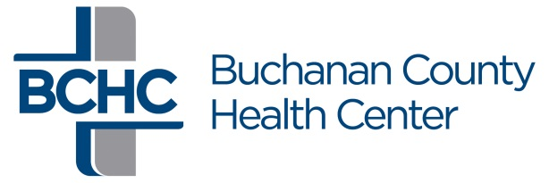
Independence Day
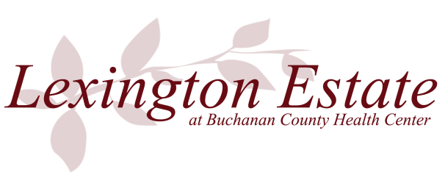
Celebration
July 3rd Poker Walk
5:00 PM

A donation of $5.00 is requested to participate.
All profits will be given to the
Walk to End Alzheimer’s

Name
Address
Phone

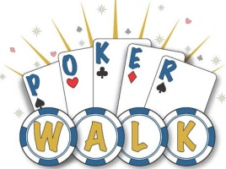
Each participant will walk 2 miles. You will receive a card at each of the 5 check points. Upon returning to the Riverwalk Parks, you will turn in your 5 card hand. Each participant will be eligible for one grand prize, donated by Buchanan County Health Center. Best 5 card poker hand wins. In case of a tie, all those with high hand will have an opportunity to “cut the deck, high card, wins”. Definition of best poker hands will be available at the registration table. Other prizes will be awarded through random drawings from all finishers. Pets are not allowed in the Riverwalk Parks.

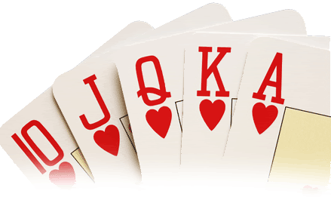
Send completed registration form to: Buchanan County Health Center Attention: Lexington Estate 1600 First Street East Independence, IA 50644 or drop off at Buchanan County Health Center, Registration. You may register at the time of walk at the Rotary Park Shelter.

Signature Date

If under 18, parent or guardian signature

Waiver: I have read the above rules and agree to abide by the rules and regulations. If I am under 18-years of age, my parent or guardian must co-sign and we both agree to be bound by the terms of this agreement, waiver and release. Knowing these facts and in consideration of my entry acceptance, admission to and/or participation in the Poker Walk and its related events, I for myself or I and my parent/ guardian, and anyone acting on my behalf, release, waive, discharge, covenant not to sue and agree to hold the City of Independence, Independence Celebrations Committee, Inc, Independence Day Celebration Committee, Independence Day Celebration donors, BCHC TWC, participating clubs, communities, organizations, vendors, emergency and support personnel, volunteers and their representative harmless from any and all claims, demands and actions of any and every kind. I have, may have or may hereafter accrue against the released parties directly or indirectly arising out of or relating in any respect to my attending or participating in the Poker Walk and its related events.

